PDF parsing with Tasks and Images
PDF Parsing Text Extraction
The first and most crucial stage in document processing is extracting text from a PDF. PDFs are available in a variety of forms; some are just text-based documents, while others have intricate layouts, tables, or scanned images. From all these variations, a good parser must consistently retrieve useable text. The main subtasks involved in PDF text extraction are broken down below.
- Loading the PDF document
The process begins by opening the PDF file using a PDF parser library. At this stage, the system checks the document structure, metadata, number of pages and determines whether the PDF is text based or image based.
- Iterate page by page
Pages are processed one page at a time. This allows the system to isolate content, maintain order and handle page specific complexities. Page level iteration ensures that text is extracted in the correct sequence and prevents mixing different sections together.
- Extract raw text blocks
For each page, the extractor pulls out raw text elements. These can come as paragraphs, lines or fragmented blocks depending on how the PDF was created. The goal here is to capture everything exactly as it appears before applying any cleanup or formatting.

- Clean and normalize text
Raw extracted text often contains unnecessary line breaks, spacing issues, encoding errors, or hidden characters. This step fixes those problems by:
- Removing extra whitespace
- Correcting broken sentences
- Fixing Unicode or encoding issues
- Normalizing punctuation and symbols
This produces clean, readable text ready for downstream processing.
- Handle special cases
Not all PDFs are straightforward. Some require additional techniques:
- Scanned PDFs Need OCR (Optical Character Recognition) to convert images into text
- Rotated or skewed text Must be detected and corrected before extraction
- Complex layouts (tables and columns) Require layout aware parsing to avoid jumbled output
Handling these cases ensures robust extraction across different document types.

- Store extracted text for chunking
After the text has been finalised and cleaned, it is typically stored in a database, JASON, or other structured format. After that, the saved text is prepared for chunking which divides the content.

Tools commonly used
Depending on the type of document and the requirements of the extraction process, a variety of tools and libraries can assist in extracting information from PDF documents. Every tool has unique capabilities:
PyMuPDF: In just a few milliseconds, text, graphics, and layout data can be retrieved using the quick and effective PyMuPDF (formerly known as Fitz) library. It is appropriate for situations where low resources needs and performance are crucial.
PDFPlumber: Third library is renowned for its precise extraction of structured text. PDFPlumber separates table sells, preserves spacing and extracts text in paragraphs with accuracy.
Tesseract OCR: Tesseract is a free and open-source OCR engine. Tesseract is used to create machine readable text from scanned or image-based PDF files that lack digital text. To build a robust, production quality pipeline for parsing PDF documents, developers frequently integrate the features of several libraries.
How text extraction work?
Text extraction from a PDF follows a clear and logical process. The goal is to take whatever is inside the PDF which are paragraphs, headings, tables or even scanned images and turn it into clean readable text that can be used later for chunking’s and embeddings, or search. Below is the process of how texts are being extracted:
- Opening the PDF
  - The first step is simply loading the PDF using a library like PyMuPDF or PDFPlumber. This allows the system to inspect the document, check how many pages it has and then understand whether the content is digital text or scanned text.
- Go through the PDF page by page
  - The extractor reads each and every page individually after the file is opened. Maintaining the natural reading sequence and making it simpler to deal with things like page numbers or headers afterward are two benefits of doing it page by page.
- Extract text blocks
  - The tool extracts the text from each page. It extracts “blocks” like paragraphs, headings or brief text excerpts rather than collecting everything as a single, enormous string. As a result, the text seems cleaner and more like it did in the original source.
- Preserve the reading order
  - Text is not always stored in PDFs in the order that people read it. As a result, the extractor arranges the blocks in the proper left to right and then top to bottom reading order. This stage guarantees that the sentences are coherent rather than disorganised.
- Clean the extracted text
  - The raw text usually needs a bit of cleanup. This includes:
    - Removing unnecessary line breaks
    - Cleaning up page numbers or repeating headers and footers
    - Fixing odd characters or encoding issues
    - Joining broken sentences that got split during extraction
  - This step transforms messy raw text into something clean and readable.
- Return clean text for chunking
  - The system returns plain text that is prepared for the subsequent processing step which is typically chunking, embedding, or storing in a vector database, after everything has been cleaned and arranged.

PDF Parsing Image Extraction
The inclusion of photos in PDF instructions is crucial since they include essential visual components such equipment illustrations and diagrams. All of the images in a PDF must be identified and appropriately extracted during processing in order to be incorporated into subsequent multimodal workflow procedures.
All photos are extracted, converted into a clear, useable format (JPEG or PNG), and given meaningful file names for convenient access. In order to maintain the connection between the image and its source, all pertinent metadata is likewise retained with the image.
How does image extraction actually work?
Typically, PyMuPDF is used to search the PDF pages throughout the extraction process. Every image on a given site will be extracted, saved in PNG format and then kept locally. In order to help in reference back during processing, metadata such as the page number and the coordinates of the specific image which will also be gathered when scanning through PDF pages
Challenges in PDF Parsing
Although a PDF may appear straightforward at first, it is actually very difficult to extract the structured data from a PDF. Optical Character Recognition (OCR) is often required to view the text contained in a PDF since it frequently does not exist in digital form.
Another problem that can have is that some image files were developed using multiple formats, making them more difficult to locate and remove. Additionally, we can discover that a large portion of the text is disorganised and does not follow the logical flow of a paragraph.
Concept Understanding
When we talk about PDF parsing, we simply mean pulling out all the useful information from a PDF manual from a PDF manual. This isn’t just the text manuals usually have a mix of:
- Normal paragraphs
- Images and diagrams
- Tables
- Page layout details
- The exact positions of objects on a page
Because these manuals contain different types of content, where we need accurate parsing to build a multimodal RAG system that can understand both text ad visuals. To do these in python, the commonly used libraries are:
- PyMuPDF (fitz): which is great for extracting both texts and images
- pdfPlumber: very good at handling text and values
- Pillow: Used to process and save images
This is the overall process which is simple:
- Open the PDF
- Read the text from each page
- Pull out any images on the page
- Save those images
- Collect useful metadata like pages numbers, coordinates and image captions.

Testing
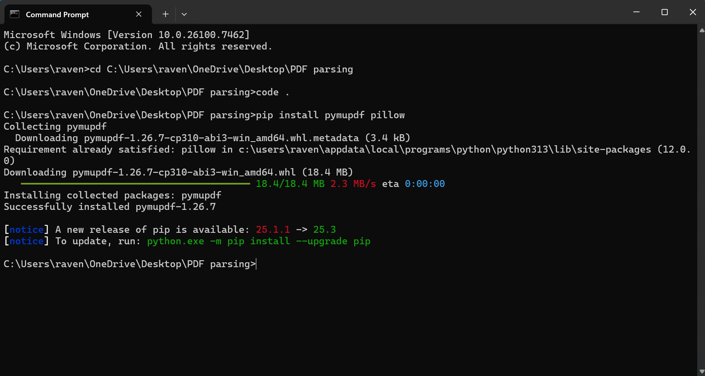
Figure 1: Running the python code in CMD

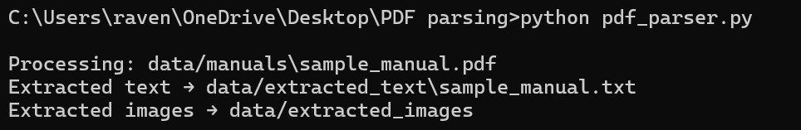
Figure 2:Output is successful

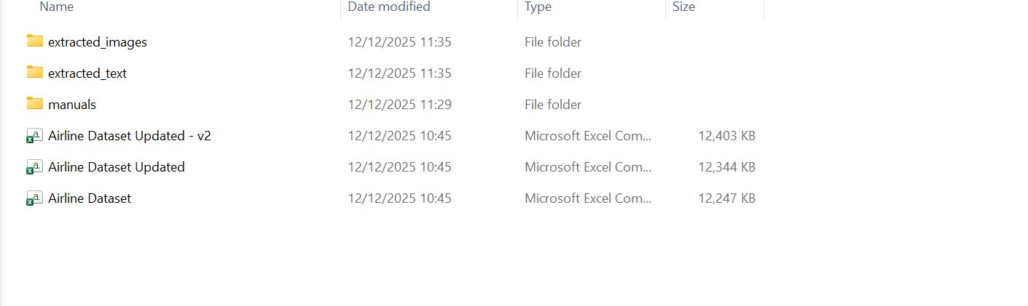
Figure 3: Folder after running the script
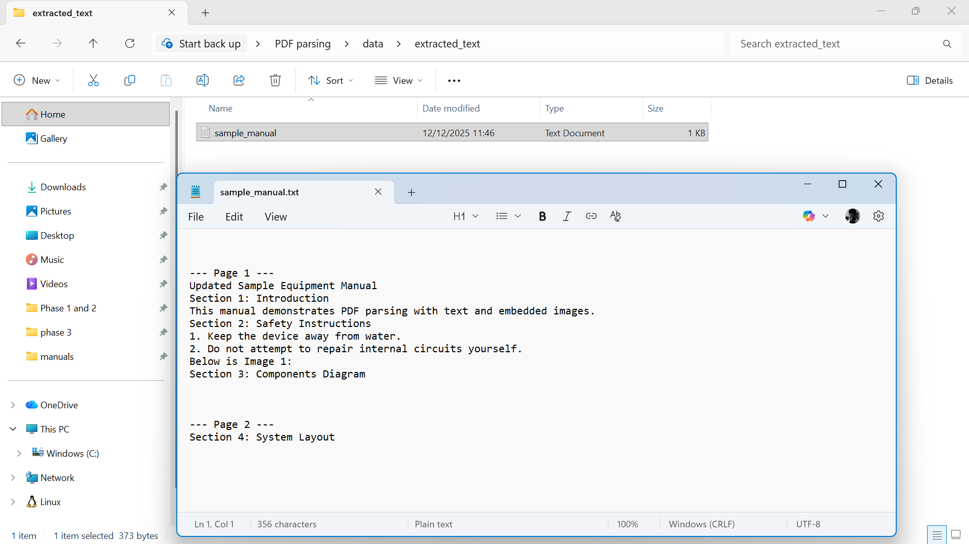
Figure 4: Extracted text
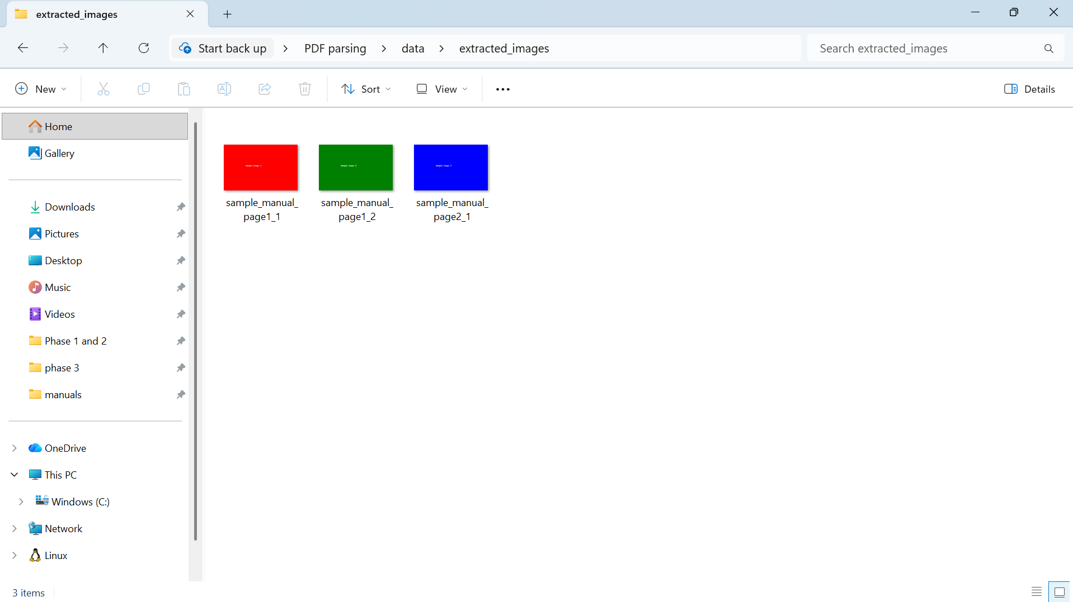
Figure 5: Extracted Images
What I did?
I used PyMuPDF to develop a PDF parser. Each page’s text and images are retrieved by the parser, which also stores them independently and obtains metadata such as page and image sizes. With digital PDFs, text extraction was quite successful, but, with scanned PDFs, it was not very clean. Although the image extraction was perfect, some graphics appeared to be low resolution and others to be rotated. Adding OCR functionality for scanned PDFs, would be the next step.
Summary
PDF parsing creates structured informational content from unstructured guides that are difficult to comprehend. During this procedure, the system will extract the text from the PDF, extract any embedded images, extract the table data from the PDF, and build the necessary metadata. The PDF's structured sections will be able to be chunked, embedded, and stored in a vector database for further use.

